MEDICAL DIAGNOSIS

AIM: To implement a prolog program for Medical Diagnosis.

OBJECTIVES:
- To implement a simple medical diagnosis system in Prolog that identifies a possible disease based on symptoms.

ALGORITHM:
- Define diseases as facts/rules.
- Define the symptoms associated with each disease.
- Ask the user for symptoms.
- Match the symptoms against disease rules.
- Display the possible diagnosis.

SYSTEM-ARCHITECTURE:
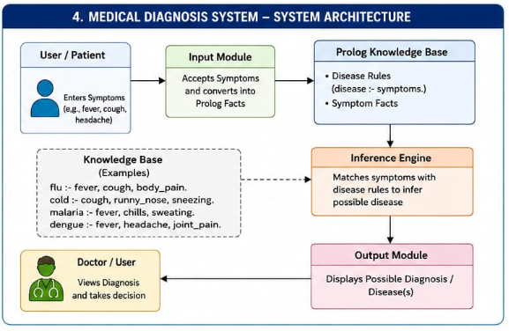

PROGRAM:
% Medical Diagnosis System

disease(flu) :-
symptom(fever),
symptom(cough),
symptom(body_pain).

disease(cold) :-
symptom(cough),
symptom(runny_nose),
symptom(sneezing).

disease(malaria) :-
symptom(fever),
symptom(chills),
symptom(sweating).

disease(dengue) :-
symptom(fever),
symptom(headache),
symptom(joint_pain).

% Symptoms entered by the user
symptom(fever).
symptom(cough).
symptom(body_pain).

OUTPUT:
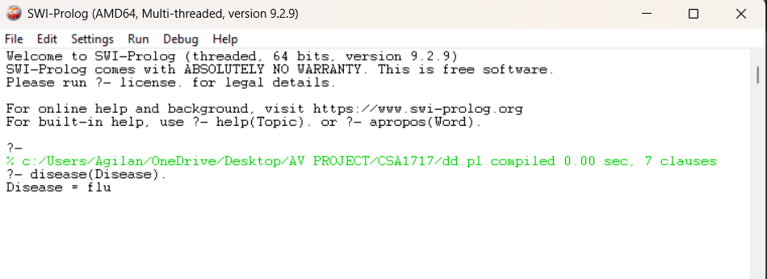

RESULT: Thus the Medical Diagnosis is implemented successfully using Prolog program.

